Task 1: Find IPv4 Address and Default Gateway Using ipconfig

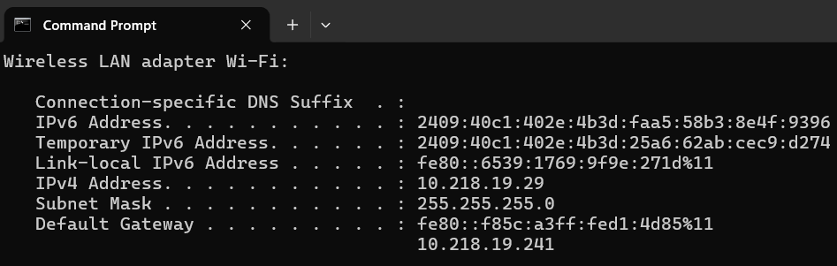

Task 2: Check Internet Connectivity Using ping

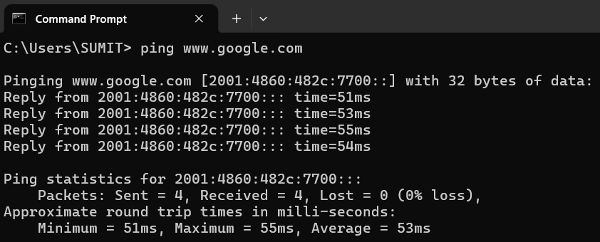
Result:
- Connectivity: Successful
- Packet loss: 0%
- Average response time: 53 ms

Task 3: Trace the Network Route Using tracert

- The trace typically completes in 14 hops as data travels from the local gateway router through ISP aggregation nodes and transit backbones to Flipkart's edge CDN.
- The tracert command identifies the network hops between computer and the destination. The actual number of hops may vary, and some routers may not respond to traceroute probes.
- Lines showing * * * and “Request timed out” still count as hops. That router just doesn’t reply to the probe.
- The count can change between runs, because Flipkart is served through a content delivery network and the path varies by ISP and time.
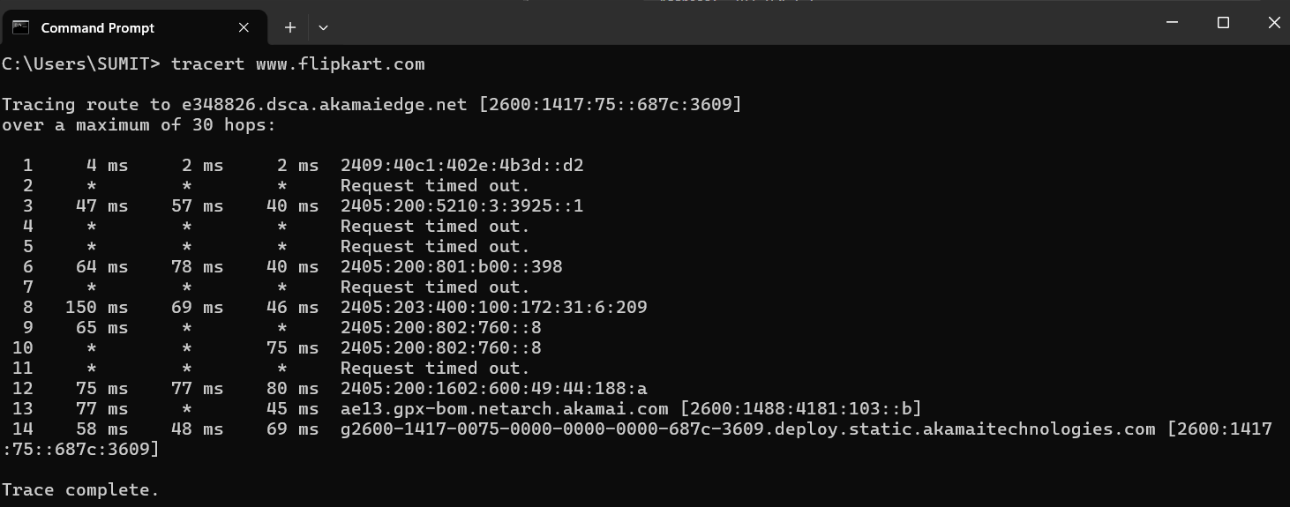

Task 4: Find the IP Address Using nslookup

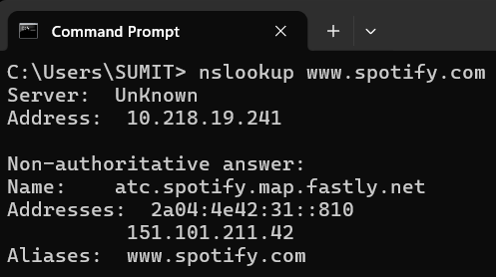
nslookup helps verify whether DNS can resolve a domain name into an IP address

Task 5: Troubleshoot a Laptop That Cannot Access Zomato

- ipconfig
- Checks the laptop’s own network setup: that it has a valid IPv4 address and a default gateway, and that the address isn’t a 169.254.x.x (APIPA) address, which means DHCP failed.
- If the IP or gateway is missing or wrong, fix the Wi-Fi or Ethernet connection first.
- ping 8.8.8.8 (an IP address, so DNS isn’t involved)
- Checks internet connectivity. Replies mean the laptop can reach the internet, so the problem is not the physical connection, the router or the ISP link.
- If it fails, ping the default gateway (from step 1) to see whether the problem is the local network or the ISP.
- nslookup www.zomato.com
- Checks DNS resolution, meaning whether the name turns into an IP address.
- If step 2 worked but this fails or times out, the cause is DNS, and the fix is to change the DNS server (e.g. 8.8.8.8 or 1.1.1.1) or run ipconfig /flushdns.
Reading the results together:
- Step 2 works and step 3 fails: DNS problem.
- Both work but the site still won’t load: run tracert www.zomato.com to see where the path breaks, then check the browser (cache, proxy), the laptop’s firewall or antivirus, or whether the site itself is down.
- Note that some sites block ping, so a failed ping www.zomato.com alone does not prove the site is down. That’s why step 2 pings an IP address and step 3 uses nslookup for the name.

